World Wide Web

***Abstract* - Incorporating new creative technology and reinventing the manner of organizing, interacting, and cooperating with others, the fast lane toward the growth of the Web has been labelled as an outright phenomena in today's society, leading to a mix of spectacular achievements and failures. The goal of this study is to comprehend and conceive the evolution of the Internet from the ground up.**

**Keyword –** World Wide Web, Web 1.0, Web 2.0, Web 3.0, Web 4.0 and its future, Characteristics, Limitations, Architecture.

1. **Introduction to World Wide Web (WWW)**

The World Wide Web, sometimes known as the web, is shortened as WWW. In 1989, CERN (European Library for Nuclear Research) launched the World Wide Web.

The World Wide Web, sometimes known as a Web, is a collection of websites or web pages maintained on web servers and accessible through the internet by local computers. Text pages, digital photos, audios, and videos, among other things, can be found on these websites. Users may access the content of these sites through the internet utilizing devices such as computers, laptops, and cell phones from anywhere in the globe. The WWW, in conjunction with the internet, allows you to retrieve and display text and media on your device.

1. **History:**

It is a project started in 1989 by Timothy Berner's Lee to allow researchers at CERN to collaborate more efficiently. The World Wide Online Consortium (W3C) is a non-profit organisation dedicated to furthering web development. Tim Berners-Lee, dubbed the "Father of the Web," is in charge of this institution.

1. **System Architecture**

The web, from the user's perspective, is a massive, international network of documents or web pages. Each page may have connections to other pages on the internet. Browsers such as Internet Explorer, Netscape Navigator, Google, Chrome, and others can be used to get and the pages. The browser retrieves the requested page, understands the text and formatting commands on it, and displays the page on the screen, appropriately formatted.

The graphic below depicts the fundamental model of how the internet operates. On the client PC, the browser is showing a web page. When a user clicks on a line of text that links to a page on the abd.com server, the browser follows the hyperlink by requesting the page from the abd.com server.

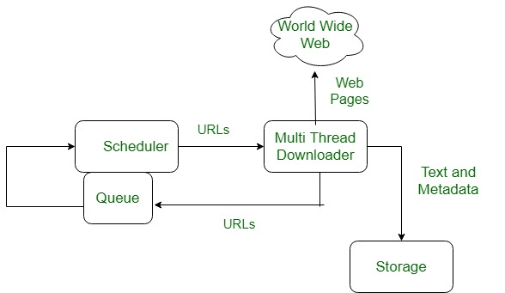

**How does the World Wide Web work?**

The internet's core client-server format, as represented in the accompanying graphic, governs how the Web functions. When users request web pages or information, the servers store and transport it to their computers on the network. A web server is a computer programme that provides web pages to people who access them using a browser. A client is the computer of a user who requests documents from a server. Users can access the papers that have been obtained using a browser that has been installed on their machine.

Web servers hold all of the websites. A website, like a person who rents a house, takes up space on a server and is kept there. When a user requests a website's Web Pages, the server hosts it, and the website owner is responsible for paying the hosting fee.

The WWW starts operating the instant you open your browser and put a URL into the address bar or search for anything on Google. In order to send information (web pages) from servers to clients, three basic technologies are used (computers of users). Hypertext Markup Language (HTML), Hypertext Transfer Protocol (HTTP), and Web browsers are examples of these technologies.

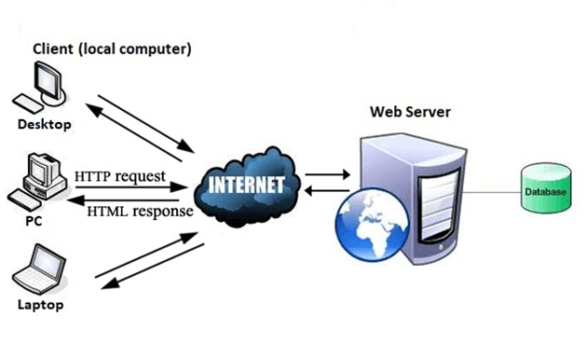

1. **Features of WWW**

* Cross-Platform Distributed Open Standards and Open Source HyperText Information System (HTIS) uses Web Browsers to give a single interface for various services that are dynamic, interactive, and evolving.
* "Web 2.0" is a term that refers to a new

1. **Components of Web**

The web is made up of three parts:

1. **HTML (Hypertext Markup Language) :**

HTML is a markup language that is commonly used to create web pages. It uses HTML elements or tags to define the structure of online pages. These tags are used to arrange material like 'header,' 'paragraph,' 'table,' 'Image,' and others. When you view a webpage, you won't see HTML tags since browsers don't show them and only utilise them to produce the text. HTML is a markup language that allows text, graphics, and other resources to be displayed in a Web browser.

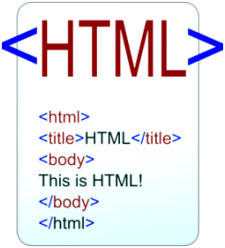

1. **URL (Uniform Resource Locator):**

A URL is a sort of universal resource identifier that contains the address of a web resource as well as the protocol used to access it. It's utilised to specify where a web resource may be found in order to view web pages. The URL directs viewers to a specific internet resource, such as a movie, webpage, or other content. When you use Google to search for anything, it will show you many URLs for resources that are all connected to your search query. The shown URLs are clickable links to the relevant webpages.

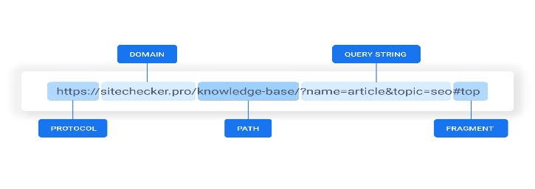

1. **Hypertext Transfer Protocol (HTTP):**

Hypertext Transfer Protocol (HTTP) is an application layer protocol that allows the World Wide Web to function smoothly and effectively. It's built on a client-server architecture. A web browser is the client that connects with the web server that hosts the website. This protocol specifies the structure and transmission of messages, as well as the actions that the Web Server and browser should do in response to certain instructions. When you type a URL into your browser, it sends an HTTP command to the Web server, which then sends the requested Web page.

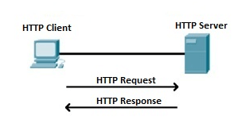

1. **Web 1.0**

In comparison to 21st-century Internet technologies, Web 1.0 was basic, stagnant, and inactive. Information, including text and photos, was provided in a static manner, with no opportunity for interaction with users or among users.

Web 1.0, often known as read-only web, was the initial stage of the World Wide Web revolution. Websites were primarily informative and featured only static material that was hyperlinked together; in other words, there was no CSS, dynamic links, or interaction such as logging in users, leaving comments on blog entries, and so on. Users on the internet were consumers of material provided by content providers during the Web 1.0 period, which lasted from 1991 to 2004. The first generation of the Internet consisted solely of static pages for the transmission of content. To put it another way, the early web allowed us to search for and read information. There was virtually little user engagement or donation of material.

1. **Characteristics of Web 1.0**

Websites during the Web 1.0 stage were characterised by the following Web 1.0 characteristics:

* **Static pages:** Pages didn't have interactive features that altered dependent on how visitors interacted with them on the website. Websites were mostly informative at the time.
* **Website material is saved in files:** The majority of website content is stored in a database on almost every modern website. This was not the case during Web 1.0, when the majority of website content was saved directly in the website files rather than in a separate database.
* **Combination of content and Layout:** Separation of webpage markup and style is a good web design technique nowadays. External style sheets are used to set the look and layout of websites on virtually every modern website. Most style was embedded within the page markup itself during Web 1.0, sometimes through abusing HTML features like tables.
* **Proprietary HTML tags:** During the Web 1.0 era, browsers tried to differentiate themselves by supporting proprietary tags, which resulted in serious incompatibility issues between websites that utilised these tags and visitors using non-supported browsers.
* **Guestbooks:** Website visitor comments were frequently submitted to a Guestbook page rather than appended directly to content pages.
* **Form e-mailing:** During the Web 1.0 era, web hosting servers seldom supported server-side scripting, which is necessary to utilise the web server to submit a form. As a result, when a website visitor clicked the Submit button on most forms during Web 1.0, their e-mail client launched, and the visitor had to e-mail their form to an e-mail address provided by the website.

1. **Limitations of Web 1.0**

The following are the key drawbacks of web 1.0:

* The material on Web 1.0 pages is only understandable by humans (web readers), and it is not machine compatible.
* The Web master is entirely responsible for keeping users up to date and managing the website's content.
* There was no online console available to execute dynamic events due to a lack of dynamic representation, i.e., to collect only static information.

1. **Web 2.0**

Web 2.0 diverged from Web 1.0 primarily in terms of information creation, sharing, and interaction. People were converted from passive viewers to creators of original material as a result of Web 2.0, which had a significant impact on business, marketing, and everyday life. Users, businesses, service providers, programmers, and organisations were able to collaborate and engage in unprecedented ways thanks to Web 2.0.

The second generation of the internet is known as Web 2.0. Dale Dougherty characterised it as a read-write web 1 in 2004. The idea came from a brainstorming session between O'Reilly and Media Live International during conference. Web 2.0 technologies enable massive worldwide populations with shared interests in social interactions to be assembled and managed.

Web 2.0 enables formal and informal arenas of everyday activities on the web by facilitating significant qualities such as participatory, collaborative, and distributed behaviours. In other words, important distinguishing elements of Web 2.0 include "relationship" technologies, "participatory media," and "social digital technology," which may also be referred to as the "wisdom web." People-centric web and participatory web are taken into consideration, as well as reading and writing on the web, allowing for bi-directional web transactions.

Web 2.0 is a web as a platform in which users can abandon many of the controls they've used in previous versions of the web. In other words, web 2.0 users have more involvement but less control. Web2.0 is not only a new version of web 1.0, but it also indicates flexible web design, creative reuse, updates, collaborative content production and modification. One of the most notable features of web 2.0 is that it supports collaboration and helps gather collective intelligence rather than web 1.0.

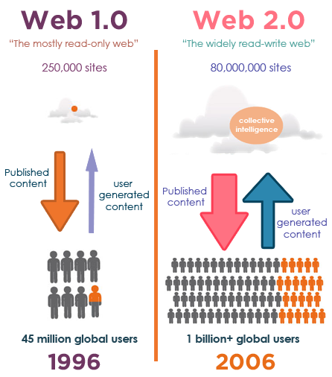

1. **Characteristics of Web 2.0:**

The classification can be used to expand on the understanding of Web 2.0 that has been acquired through various definitions:

* **Technology Centric Technology:** The web has evolved into a platform with software that extends beyond a single device. Technology connected with blogs, wikis, podcasts, and RSS feeds, for example.
* **Business Centric Characteristics:** It is a method of designing software and enterprises. The migration to the internet as a platform, as well as an endeavour to grasp the rules for success on that platform, has sparked a business revolution in the computer sector.
* **User Centric Characteristics:** The term "social web" is frequently used to describe websites that are made up of communities. It's all about content management and innovative ways for people to communicate and connect. The web application promotes communal knowledge development, social networking, and information exchange between users.

1. **Tools and Features of Web 2.0**
2. **Folksonomy —** unrestricted classification of data; enables users to classify and locate data collectively (e.g. "tagging" of websites, images, videos or links)
3. **Rich User experience -** Dynamic content that responds to human interaction makes for a rich user experience (e.g., a user can "click" on an image to enlarge it or find out more information)
4. **User engagement -** Via assessment, review, and online commentary, information flows two ways between the site owner and the site users. User-generated content (UGC) is often created by site users for the benefit of others (e.g., Wikipedia, an online encyclopedia that anyone can write articles for or edit)
5. **Software as a Services (SaaS) -** Web 2.0 sites created APIs to facilitate automated usage, such as by a Web "app" (software application) or a mashup.
6. **Mass Participation -** Near-universal online access leads to a divergence of issues, moving away from the traditional Internet user base (who tended to be hackers and computer enthusiasts) and toward a broader range of consumers.

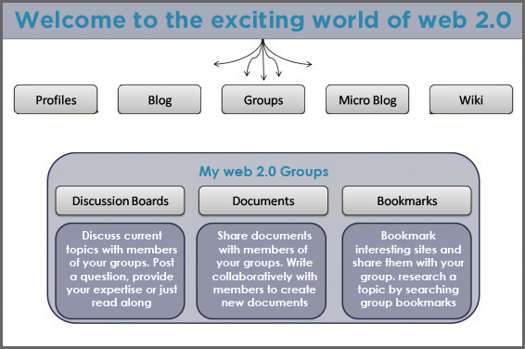

**Advantages of Web 2.0**

* Available at any time and in any location.
* Learners can actively participate in the creation of knowledge.
* Everyone is both the author and the editor, and each edit can be monitored.
* The wiki is updated in real time, and it provides scholars with extra resources.
* It allows for real-time conversation.
* A wide range of media is available.

1. **Disadvantages of Web 2.0**

* **Data Privacy and Monetization:** In the initial few months or years after their founding, most software companies come up with a billion-dollar plan that revolves around major client acquisition. Companies like Facebook, Google, Twitter, and others focus on building a lightweight web and mobile application that can enroll large numbers of people for free. These businesses are significantly backed by venture investors. These businesses begin to acquire personal information over time.

They may either advertise based on the data acquired or sell it to other companies once they have enough data. The majority of the Internet nowadays is centered on this problem. Billions of people are at the mercy of a few businesses that have far more data than they require. Data exploitation has resulted in several privacy and legal challenges throughout the world.

* **Security:** The end-user has the least control over the data given by Web 2.0 apps, which is a key disadvantage. Because the businesses who hold the aforementioned platforms control the majority of the data given, this is the case.During data breaches, this data might be disclosed to the public, exposing sensitive information such as health, banking information, personal communications, and so on.

Banks and the government, in addition to these groups, are additional bodies that control your free will and expression. If you don't follow official regulations, your bank account, for example, might be blocked or closed. Web 2.0 is being buried in the digital graveyard due to a clash of power, autonomy, data privacy, and ownership.

1. **Web 3.0**

Intelligence is the defining feature of Web 3.0. This intelligence may be seen not just in interactions between people and websites, but also in interactions between software. Plus, there's a lot more. The distinction between Web 2.0 and Web 3.0 is multifaceted.

Web 3.0 apps, also known as decentralised applications or dApps for short, are developed on top of blockchains or decentralised networks, as opposed to Web 2.0, where developers build and deploy applications utilising a centralized database. Peer-to-peer nodes (a node is analogous to a server) or a mix of both are used to link them. These apps are referred to be decentralised apps (dApps) if they follow a crypto-economic system.

Web3.0 supports a global database and a web-oriented architecture, which was formerly referred to as a web of documents. It mostly concerns with static HTML documents, although dynamically produced sites and other formats should, whenever feasible, adhere to the same basic layout principles, and links should be between or inside publications. The web of documents was created for human consumption, with main objects being papers and secondary objects being linkages between documents (or parts of them). Content and connection semantics are implicit, and the degree of structure between objects is minimal.

In decentralised apps, cryptocurrency is quite important. Cryptocurrency serves as a financial incentive for network participants to provide the best possible service while conducting a transaction on the blockchain. These protocols may differ, and the incentives are generally based on computer storage, transaction ease and speed, bandwidth, hosting, identification, and other online services provided by cloud providers. This is analogous to paying for an AWS service, only the funds go directly to the network members.

FileCoin, Arweave, and Livepeer are just a few of the online infrastructure protocols available. They exist side by side and provide the same functionality as the Ethereum Blockchain's services. These tokens may be used only for the development of dApps and may offer financial incentives to network members.

**Why Web 3.0?**

* **Centralized systems have issues:** Centralized platforms have a predictable life cycle. They do everything they can to attract users and third-party complements such as artists, developers, and corporations at first.

They do so in order to boost their network impact. Platforms' control over users and third parties continuously expands as they go up the adoption S-curve.

* **Innovation Sufficiency:** The shift from collaboration to competition appears to be a bait-and-switch to third parties. The finest entrepreneurs, developers, and investors have learnt not to build on centralized systems over time. As a result, creativity has been strangled.
* **Ownership and Control Decentralization:** Web 3 allows for decentralised ownership and governance. Tokens, both non-fungible (NFTs) and fungible (FTs), allow users and creators to own parts of internet services.

1. **Characteristics of Web 3.0**

* **Sematic Web:** The semantic web is a collaborative effort led by the World Wide Web Consortium, an international standards organisation. The Semantic Web provides a standard architecture that allows data to be shared and reused across application, company, and community borders.

The Semantic Web's major goal is to accelerate the growth of the present web by making it easier for users to find, share and integrate in new ways. As initially envisioned, the Semantic Web is a framework that allows robots to comprehend and reply to complicated human requests based on their meaning. The necessary information sources must be semantically organized in order to achieve this comprehension.

The semantic web is built in stages, with each phase adding a layer on top of the previous:

* **Unicode and URI:** Unicode is used to represent any character uniquely, regardless of the language in which it was written, and uniform Resource Identifier (URI) is a universal identifier for all resources. Unicode and URI's capability may be summarized as the supply of a unique identifying method within the semantic web's language stack.
* **XML:** XML is a markup language for creating structured online content using a user-defined vocabulary. XML is particularly well suited to transmitting documents over the internet. No built-in method exists in XML to communicate the meaning of a user's new tags to other users.
* **RDF:** Resource Description Framework is a fundamental data paradigm for expressing simple statements about online objects, similar to the entity-relationship model. A web-based approach for defining information. RDF is a technology that allows you to represent the meaning of words and concepts in a way that computers can understand.
* **Logic Layer:** This layer is used to improve ontology languages and enable for the creation of application-specific declarative knowledge.
* **Proof Layer:** The actual deductive method, as well as the encoding of proofs in web languages and proof checking, are all part of the Proof Layer.
* **Trust Layer:** The Trust Layer will arise as a result of the usage of digital signatures and other types of information based on trusted agents' recommendations or rating and certification organizations and consumer groups. The semantic web isn't just for publishing material on the internet. It's all about connecting disparate data sets through linkages. In 2007, Berners-Lee published the linked data principles, a set of standards for publishing and connecting data on the web.

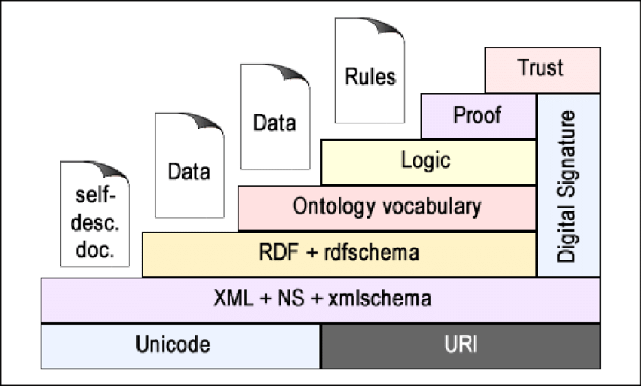

* **Spatial Web and 3D Graphics:** Another feature that distinguishes Web 3.0 from Web 2.0 is 3D graphics. The three-dimensional architecture enables for the creation of a more realistic and interesting cyber world, as well as the expansion of economic potential. Architecture, online gaming, real estate, e-commerce, tourism, and other businesses have already begun to use 3D visuals to market their products and services. The Spatial Web, on the other hand, is thought to represent the future of Web 3.0, blurring the gap between the physical and digital worlds.
* **Artificial Intelligence:** Web 3.0 has become more sophisticated and efficient because to AI technologies. By forming links between diverse bits of information, robots can now comprehend text, audio, video, and photo content in a more meaningful way. AI can distinguish between useful and worthless data, as well as bogus news and facts. It can also estimate consumer demand and provide individualized customer care, both of which are critical for organisations.
* **Cryptocurrency and Blockchain:** Without addressing the connection between Web 3.0 and blockchain and cryptocurrency technology, which are already altering the financial industry, a description of Web 3.0 would be insufficient. By making Web 3.0 more open and safe, and permitting total ownership and control of the data, blockchain helps overcome the key flaws of Web 2.0. The options are infinite, and they include the use of definite solutions, tokenization, cloud storage, smart contracts, and other technologies to increase efficiency and enhance confidence. You may utilise 4irelabs consulting services to take advantage of blockchain and learn about Web 3.0 blockchain possibilities.

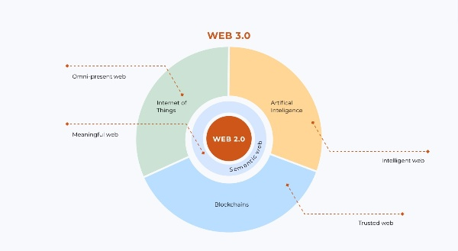

1. **Examples of Web 3.0 Application**

Web 3.0 is already widely used in a variety of fields, including messaging, social networking, exchange services, storage, banking, streaming, and surfing. To assist you grasp the scale of Web 3.0 adoption, below are some examples of Web 3.0 apps:

* **E-Chat:** This blockchain-based new-generation messenger provides excellent productivity and security. To provide decentralised and secure services, it employs peer-to-peer (P2P) technology, IPFS, and the MTProto encryption algorithm. Users may use this messenger to not only talk safely, but also to send bitcoin.
* **Storj:** Storj is a cloud-based service that uses blockchain to securely store user data. When compared to Dropbox, Google Drive, and other services, Storj's key benefits are its resilience to outages and privacy breaches.
* **Sapien:** Sapien is a decentralised social news network that uses decentralization, democracy, interoperability, and tokenization to tackle fake news. This Web 3.0 example demonstrates how modern technology may help social media deliver more reliable, ad-free services. Sapien shows how Web 3.0 technologies may be used to eliminate censorship, safeguard privacy, and protect free expression.
* **Brave:** Decentralization, efficiency, security, and a lower cost define this browser that integrates IPFS. Users who are willing to ignore censorship and connection concerns can have a more private and robust experience. Brave also has a better performance due to the fact that it blocks advertisements on websites. This feature allows users to give money to their favorite websites.
* **Ethlance:** The Ethereum blockchain technology is used in this remote work platform. Users may hire and work using Ether as a coin. Ethlance, unlike other services, has no service fees or membership restrictions.

1. **Advantages of Web 3.0**

* **Efficiency:** Artificial intelligence improves the efficiency of online browsing and Internet use by making search results more exact and user-oriented. Greater efficiency can be especially beneficial for organisations looking to elevate their consumers' experiences. It may also be accomplished through the use of artificial intelligence and neural networks in commercial decision-making.
* **Trust and security**: Web 3.0 technologies, such as blockchain, are less vulnerable to hacking and privacy breaches due to their decentralization and distributed nature. Web 3.0 presents a chance to break down monopolies by providing people total control over their data and improving cooperation. As a result, organisations who use Web 3.0 can benefit from increased client trust, more income, and a competitive edge.
* **Uninterrupted Use**: There is no possibility of service outages in Web 3.0 since data is kept in nodes. Furthermore, several backups guarantee that data is adequately safeguarded.
* **Access:** Web 3.0 also dismantles the boundaries that have previously prevented individuals from using Internet technology and services. Users' online behaviors are not bound by their location, income, gender, or other demographic traits thanks to blockchain.
* **Ownership of data:** Web 3.0 uses encryption to provide consumers total control and ownership of their data. It means that major corporations like Google, Facebook, Amazon, and others will no longer use private data for marketing and advertising.

1. **Disadvantages and Challenges in Implementation**

* **Appropriateness for Advanced Devices Only:** Users using less sophisticated devices will not be able to access Web 3.0. As a result, in order for this technology to actually become general, the qualities of devices need be broadened. Otherwise, only a small number of individuals would be able to use Web 3.0.
* **Vastness:** The World Wide Web is massive, with billions of pages. Data redundancy may develop if all semantically redundant words have not yet been eliminated.
* **Nature is a complicated beast:** For the time being, only the most tech-savvy Internet users will be able to fully appreciate and exploit Web 3.0's possibilities. Less experienced users are put off by their complexity, which slows the uptake of Web 3.0 technology.
* **Vagueness:** The ambiguity of user inquiries, the ideas represented by content providers, the matching of query words to provider terms, and the attempt to merge diverse knowledge bases with overlapping but somewhat distinct concepts all contribute to this.
* **Rendering Web 1.0 Obsolete:** Rendering Web 1.0 Outdated Websites built on the old Web 1.0 architecture have become obsolete, and updating them to meet new expectations costs time and money. On the one hand, encouraging firms to engage in technology advancement to improve consumer experiences is a good thing. Those without the means to adapt to Web 3.0, on the other hand, may lose a competitive advantage.
* **Inconsistency:** These are logical inconsistencies that will undoubtedly occur throughout the creation of big ontologies and when ontologism from different sources is integrated.
* **Problems with Implementation:** Experts believe that more work has to be done to adopt Web 3.0 and make it more useful, efficient, and accessible. Despite the fact that Web 3.0 technology is becoming increasingly intelligent and efficient, it does not always meet the demands of consumers. More research is needed to solve the difficulties of ambiguity and vastness, as well as to educate machines to pick and give relevant, trustworthy, accessible, and high-quality data.
* **Deception:** This occurs when the information's producer purposefully misleads the information's consumer.

1. **Comparison amongst the Web**

|  |  |  |
| --- | --- | --- |
| Web 1.0 | Web 2.0 | Web 3.0 |
| 1996 – 2004 | 2004 - 2016 | 2016 + |
| The Hypertext Web | The Social Web | The Somatic Web |
| Only read | Web Reading and Writing | Web-based application |
| Companies Publish Content | Content is created by people. | Users create applications that allow people to engage and produce information. |
| One Directional | Bi-Directional | Virtual environment with several users |
| Static content | Dynamic content | Web 3.0 is strangely undefinable. The online learning, AI and 3D. |

1. **Conclusion**

The WWW began with only one purpose, but with great potential and a collective dream of its inventors that has yet to be completely fulfilled. The WWW and the internet have a slew of issues and can have harmful societal implications. It does, however, have a number of advantages, particularly in terms of global and local communication.

No one knows what the internet and the WWW will look like in another 25 years, but it will almost certainly remain a big part of our daily lives and will only continue to expand alongside us.

1. **References**

* [**https://www.linkedin.com/pulse/what-web-30-muhammad-shahzad/**](https://www.linkedin.com/pulse/what-web-30-muhammad-shahzad/)
* [**https://nftuniversity.com/what-is-web-3-0/**](https://nftuniversity.com/what-is-web-3-0/)
* [**https://4irelabs.com/articles/what-is-web-3-0/**](https://4irelabs.com/articles/what-is-web-3-0/)
* [**https://permission.io/blog/web-3-0/**](https://permission.io/blog/web-3-0/)
* [**https://www.javatpoint.com/what-is-world-wide-web**](https://www.javatpoint.com/what-is-world-wide-web)
* [**https://www.geeksforgeeks.org/world-wide-web-www/**](https://www.geeksforgeeks.org/world-wide-web-www/)
* [**https://owenckp2015.weebly.com/conclusion.html**](https://owenckp2015.weebly.com/conclusion.html)